Name | Karan Chougule
Roll no | 24204B0002
Batch | 01
Subject name | Python Programming & Data Structure
Teacher Name | Ms. Rasika Patil

Experiments | 3
Title | *a) Develop python program to demonstrate use of control loops:  i) while  ii) do while  *b) Develop program to demonstrate use of for loop in python (e.g.: various pattern building, printing multiplication table, checking palindrome number etc.)
Theory
Looping constructs allow repeated execution of a block of code.
• While Loop runs as long as a condition is true.
• Do-While Simulation is implemented in Python using while True with a break.
• For Loop is used to iterate over sequences or ranges.
These constructs help build logic for patterns, number processing, and iterative operations.
Syntax
• while condition:
• for i in range():
• break
• continue

Here's an explanation of how they work and their significance in solving iterative problems:
1. for Loops:
- for loops are used when you know the number of iterations or when iterating over a sequence (e.g., lists, tuples, strings).
- They iterate over each item in a sequence, executing a block of code for each Iteration.

Syntax | Example
for item in sequence:  # Code block to execute for each item | numbers = [1, 2, 3, 4, 5]  for num in numbers:  print(num)
2. while Loops:
A while loop is used to repeatedly execute a block of code as long as a specified condition is true. It continues iterating until the condition becomes false.
Syntax | Example
while condition:  # Code block to execute while condition is true | num = 1  while num <= 5:  print(num)  num += 1

3. Nested Loops:
You can nest loops within each other to perform more complex iterations, such as iterating over nested lists or performing matrix operations.
Syntax | Example
for outer_variable in outer_sequence:  table # Code block for the outer loop for rows  inner_variable in inner_sequence:  # Code block for the inner loop space | # Nested loops to create a multiplication  for i in range(1, 6): # Outer loop for the  for j in range(1, 6): # Inner loop for the columns  print(i * j, end='\t') # Print the product with a tab  print() # Print a new line after each row

Loop Control Statements:
Python provides loop control statements to modify the behavior of loops:
- break: Terminates the loop prematurely, exiting the loop entirely.
for i in range(5):
if i == 3:b
break print(i)
- continue: Skips the rest of the current iteration and moves to the next iteration. for i in range(5):
if i == 3:
continue print(i)
- pass: Placeholder that does nothing. It is used when a statement is syntactically required but no action is needed.
for i in range(5):
pass # Placeholder for future code

Programming Questions with Answer
FOR LOOP
1 | Print multiplication table of a number
SCRIPT | print("Rasika,02")  n = int(input("Enter a number: "))  for i in range (1,11):  print (n,"x",i,"=",n*i)
OP | 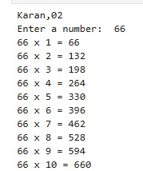
2 | Print a star pattern  * ** *** **** ***** * *** ***** *** * 1010101 10101 101 1
SCRIPT | print("Karan,02")  for i in range(1,6):  print("*" * i,"_" * i)
OP | 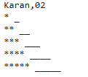
3 | Count digits in a number
SCRIPT | num = int(input("Enter a number: "))  count = 0  if num == 0:  count = 1  else:  while num != 0:  count += 1  num //= 10  print("Number of digits:", count)
OP | 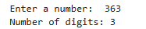
WHILE LOOP
1 | Print numbers from 1 to 20
SCRIPT | print("Karan,02")  for i in range(1,20):  print(i)
OP | 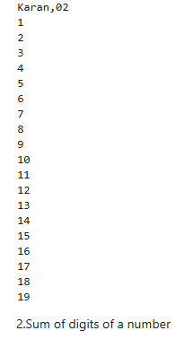
2 | Sum of digits of a number
SCRIPT | print("Karan,02")  num=int (input("Enter a number: "))  total=0  while num > 0:  total += num % 10  print("total",total)  num //= 10  print("num",num)  print("Sum of digita:", total)
OP | 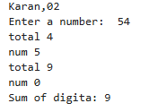
3 | Reverse a number
SCRIPT | print("Karan,02")  num = int(input("Enter a number: "))  reverse = 0  while num > 0:  reverse = reverse * 10 + num % 10  num //= 10  print("Reversed number:", reverse)
OP | 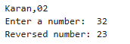
4 | Program to check if a number is a palindrome using for loop
SCRIPT | num = int(input("Enter a number: "))  original = num  reverse = 0  for _ in range(len(str(num))):  digit = num % 10  reverse = reverse * 10 + digit  num //= 10  if original == reverse:  print("The number is a palindrome")  else:  print("The number is not a palindrome")
OP | 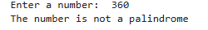
DO-WHILE SIMULATION
1 | Keep taking input until the user enters 0
SCRIPT | while True:  num = int(input("Enter a number (0 to stop): "))  if num == 0:  break
OP | 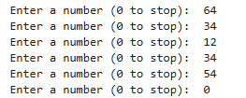
2 | Menu-driven calculator
SCRIPT | while True:  print("\n--- Menu Driven Calculator ---")  print("1. Addition")  print("2. Subtraction")  print("3. Multiplication")  print("4. Division")  print("5. Exit")  choice = int(input("Enter your choice: "))  if choice == 5:  print("Exiting calculator...")  break  if choice >= 1 and choice <= 4:  a = float(input("Enter first number: "))  b = float(input("Enter second number: "))  if choice == 1:  print("Result =", a + b)  elif choice == 2:  print("Result =", a - b)  elif choice == 3:  print("Result =", a * b)  elif choice == 4:  if b != 0:  print("Result =", a / b)  else:  print("Division by zero is not allowed")  else:  print("Invalid choice! Please try again.")
OP | 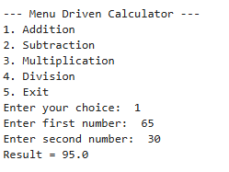  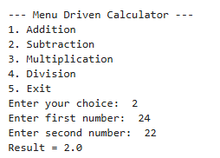  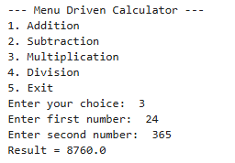  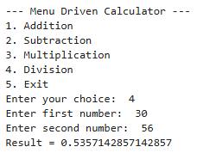  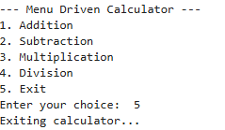
3 | Continue asking for password until correct
SCRIPT | correct_password = "python123"  while True:  password = input("Enter password: ")  if password == correct_password:  print("Access granted")  break  else:  print("Incorrect password. Try again.")
OP | 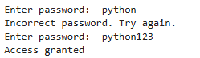
Debugging Questions with Corrected Answers
1 | Debug the following code  Wrong code:  i = 1  while i <= 5  print(i)  i = i + 1
OP | Error: 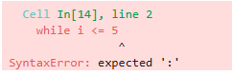  Correct code: 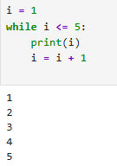
2 | Debug the following code  Wrong code:  for i in range(1, 10)  print(i)
OP | Error: 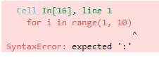  Correct code: 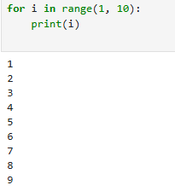
Conclusion | In this program, we successfully printed different star and number patterns using loops in Python. By controlling the number of iterations with for loops and adjusting the printing logic, we were able to generate increasing, decreasing, and symmetrical patterns. This exercise helps in understanding looping concepts, nested logic, and pattern design, which are essential for building strong programming fundamentals.
Performance Indicators |  | Teachers Dated and Signature
Process Related  (15 M) | Product Related  (10 M) | Total (25 M)

